*1.Wap to find the sum of two numbers using function without argument and return type?*

#include<stdio.h>

int sum ()

{

int a,b,s;

printf("enter any two numbers:");

scanf("%d%d",&a,&b);

s=a+b;

printf("sum is %d",s);

}

int main()

{

sum();

return(0);

}

*output is :*

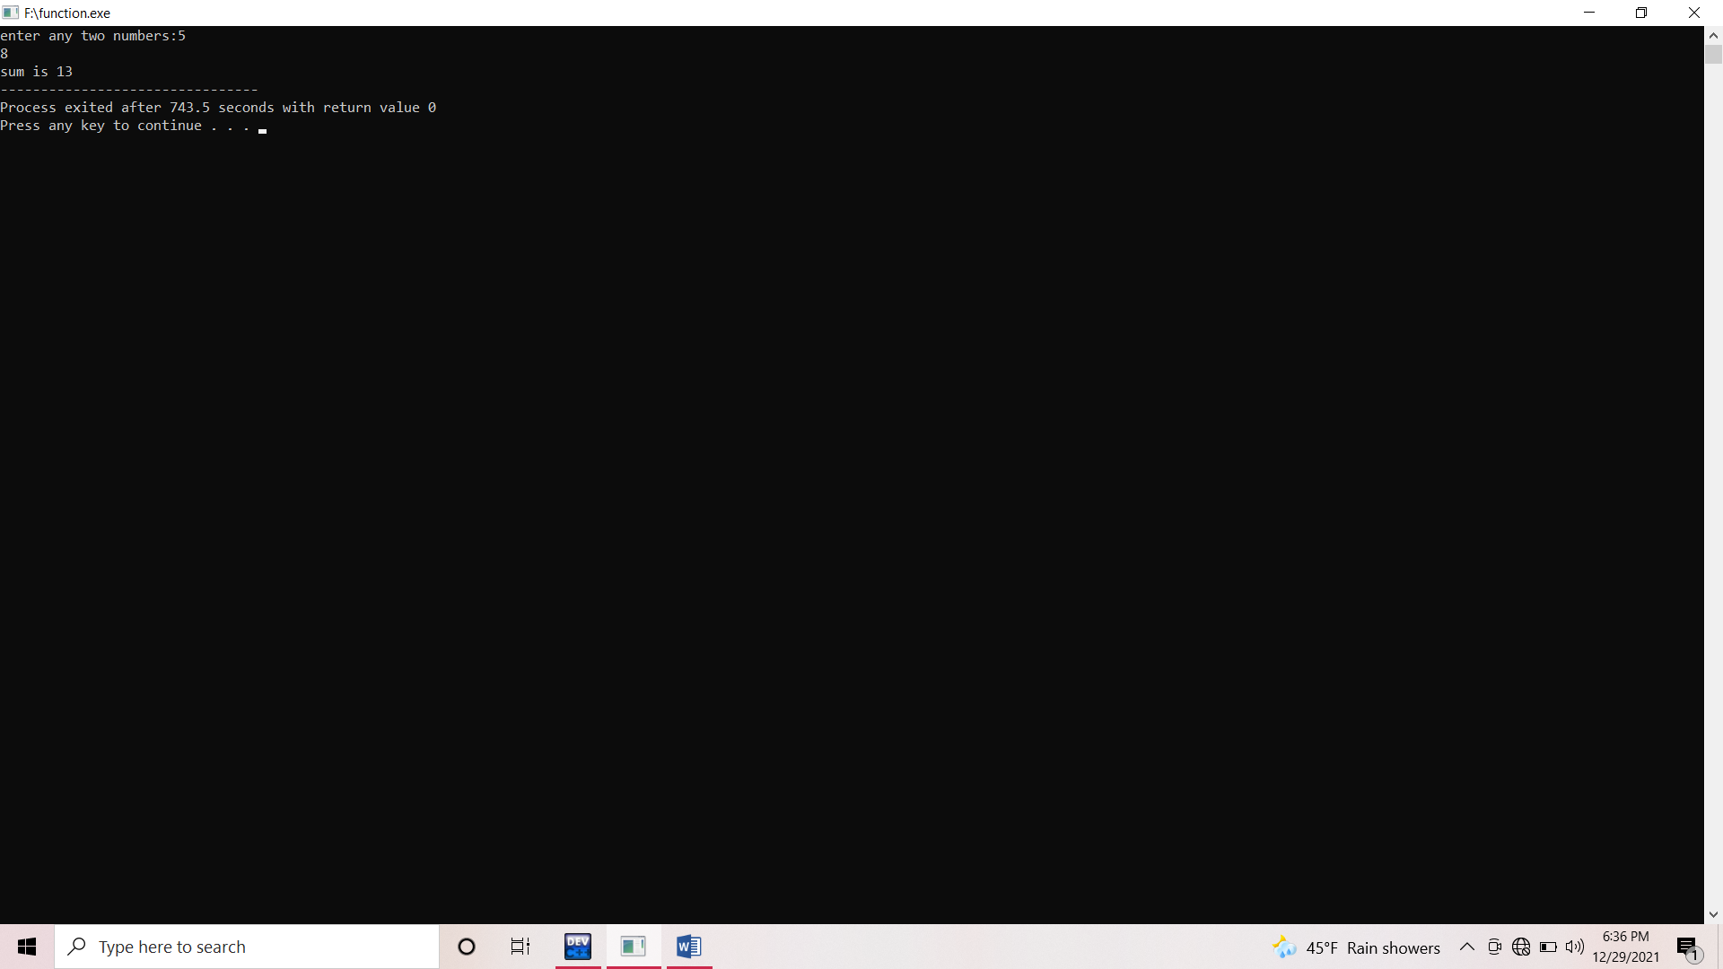

2. *Wap to find the sum by using without argument but with return type?*

*#include<stdio.h>*

*int sum()*

*{*

*int a,b,s;*

*printf("Enter any two numbers:");*

*scanf("%d%d", &a,&b);*

*s=a+b;*

*return(s);*

*}*

*int main()*

*{*

*int s1;*

*s1=sum();*

*printf("the sum is:%d",s1);*

*return(0);*

*}*

*Output is*

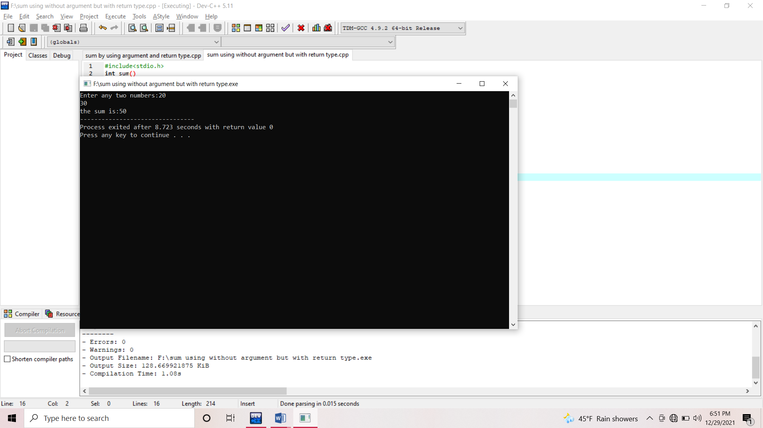

*3. Wap to find the sum of two numbers by using with argument but without return type?*

*#include<stdio.h>*

*void sum(int a, int b)*

*{*

*int s;*

*s=a+b;*

*printf("the sum is:%d",s);*

*}*

*int main()*

*{*

*int n1,n2;*

*printf("Enther any two numbers:");*

*scanf("%d%d",&n1,&n2);*

*sum(n1,n2);*

*return(0);*

*}*

*Output is*

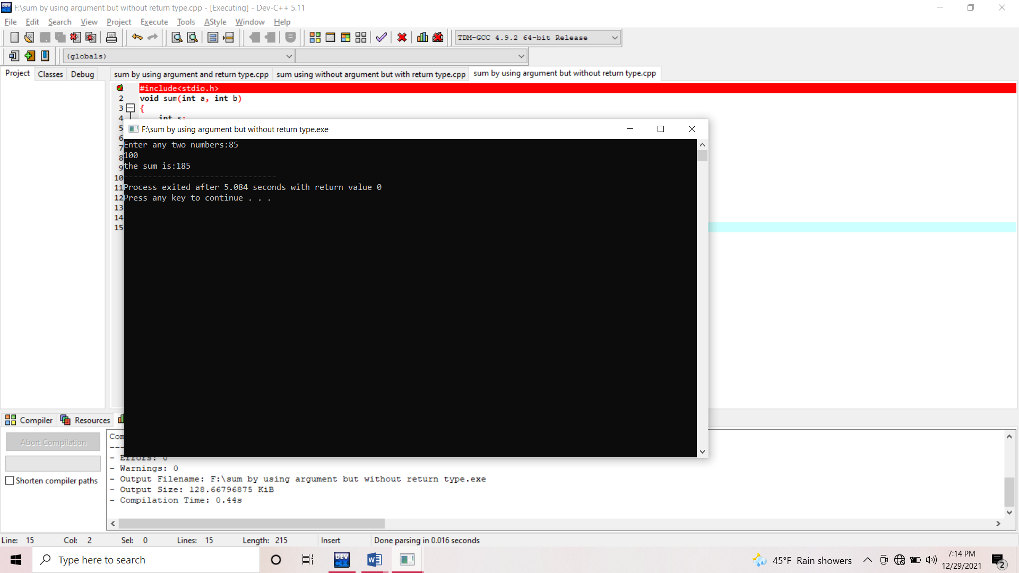

*4. Wap to find the sum by using both function arguments and return type?*

*#include<stdio.h>*

*int sum(int a, int b)*

*{*

*int s;*

*s=a+b;*

*}*

*int main()*

*{*

*int n1,n2,s1;*

*printf("Enter any two numbers:");*

*scanf("%d%d",&n1,&n2);*

*printf("The sum is: &d",s1);*

*return(0);*

*}*

*Output is:*

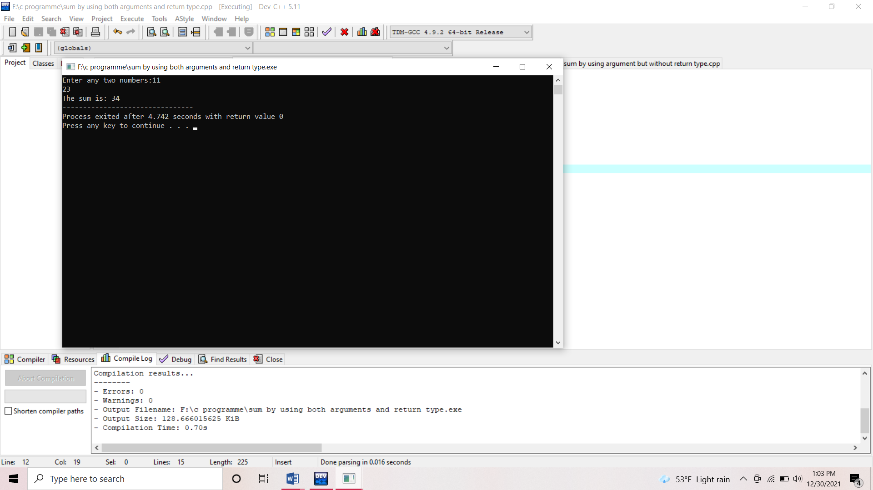

*5. Wap to check whether the number is palindrome or not by using function?*

*#include<stdio.h>*

*void palindrome()*

*{ int n, n1, rev=0,r;*

*printf("Enter a number:");*

*scanf("%d",&n);*

*n1=n;*

*while(n>0)*

*{*

*r=n%10;*

*rev=rev\*10+r;*

*n=n/10;*

*}*

*if (n1==rev)*

*printf("%d is palindrome",n1);*

*else*

*printf("%d is not palindrome",n1);*

*}*

*int main()*

*{*

*palindrome();*

*return(0);*

*}*

*Output is:*

*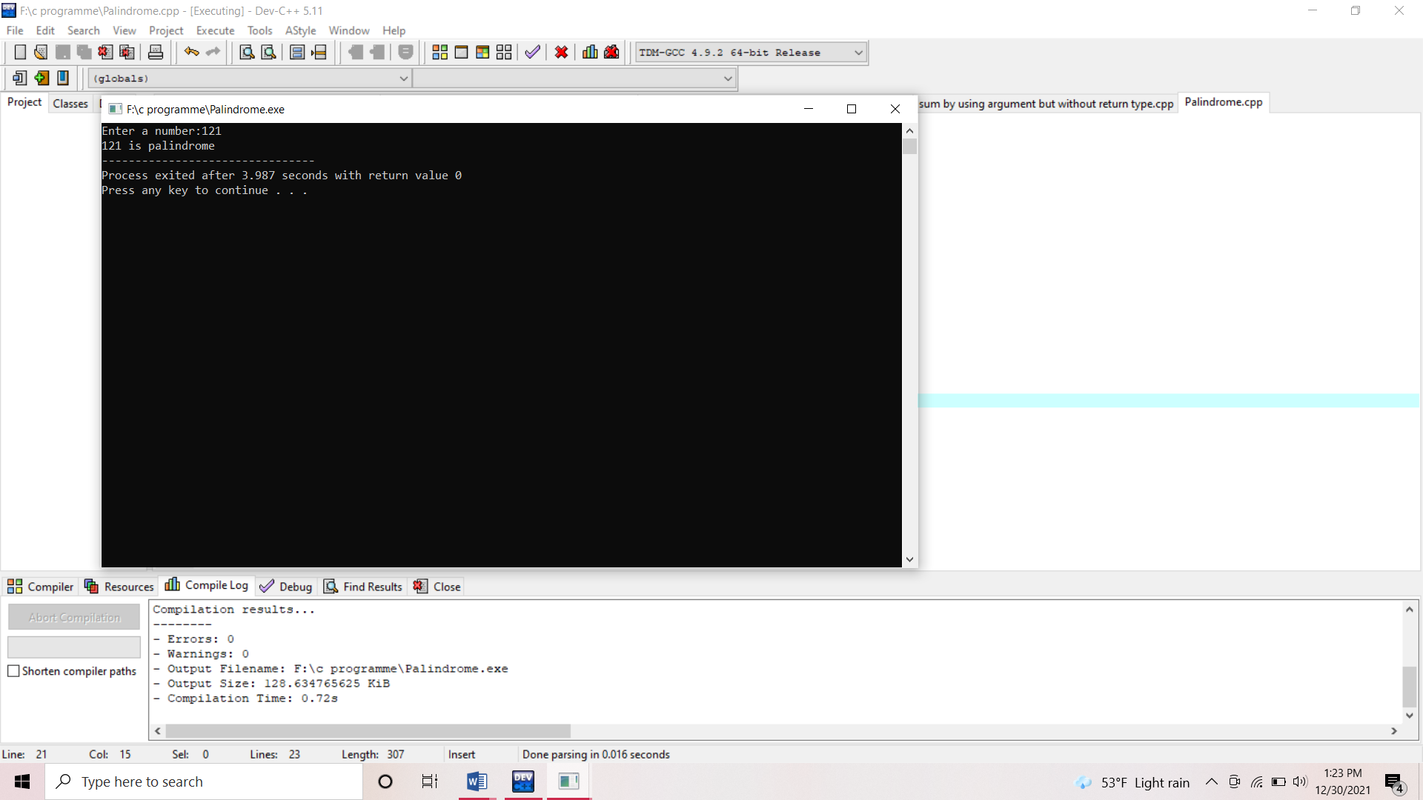*

*6.WAP to find whether the number is Armstrong or not?*

*#include<stdio.h>*

*int armstrong()*

*{*

*int n,n1,sum=0,r;*

*printf("Enter a number:");*

*scanf("%d",&n);*

*n1=n;*

*while(n>0)*

*{*

*r=n%10;*

*sum=sum+(r\*r\*r);*

*n=n/10;*

*}*

*if(n1==sum)*

*printf("%d is armstrong.",n1);*

*else*

*printf("%d is not armstrong.",n1);*

*}*

*int main()*

*{*

*armstrong();*

*return(0);*

*}*

*Output is :*

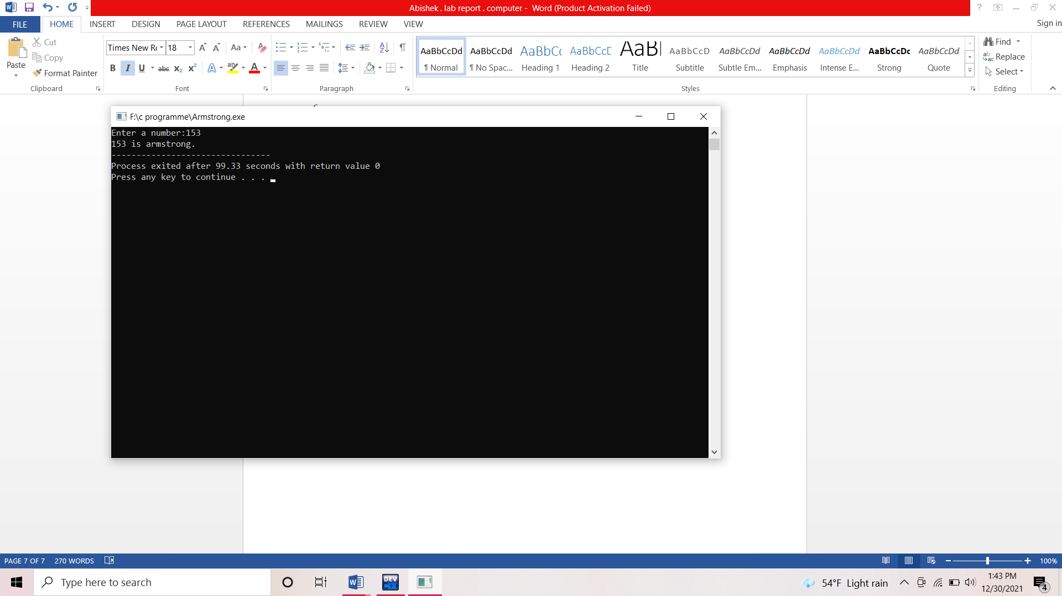

*7. WAP to find the factorial of a number by using recursion?*

*#include<stdio.h>*

*int fact(int n)*

*{*

*if(n==1)*

*return(1);*

*if(n>1)*

*return(n\*fact(n-1));*

*}*

*int main()*

*{*

*int n1;*

*printf("Enter a number:");*

*scanf("%d",&n1);*

*printf("Factorial is:%d",fact(n1));*

*return(0);*

*}*

*Output is:*

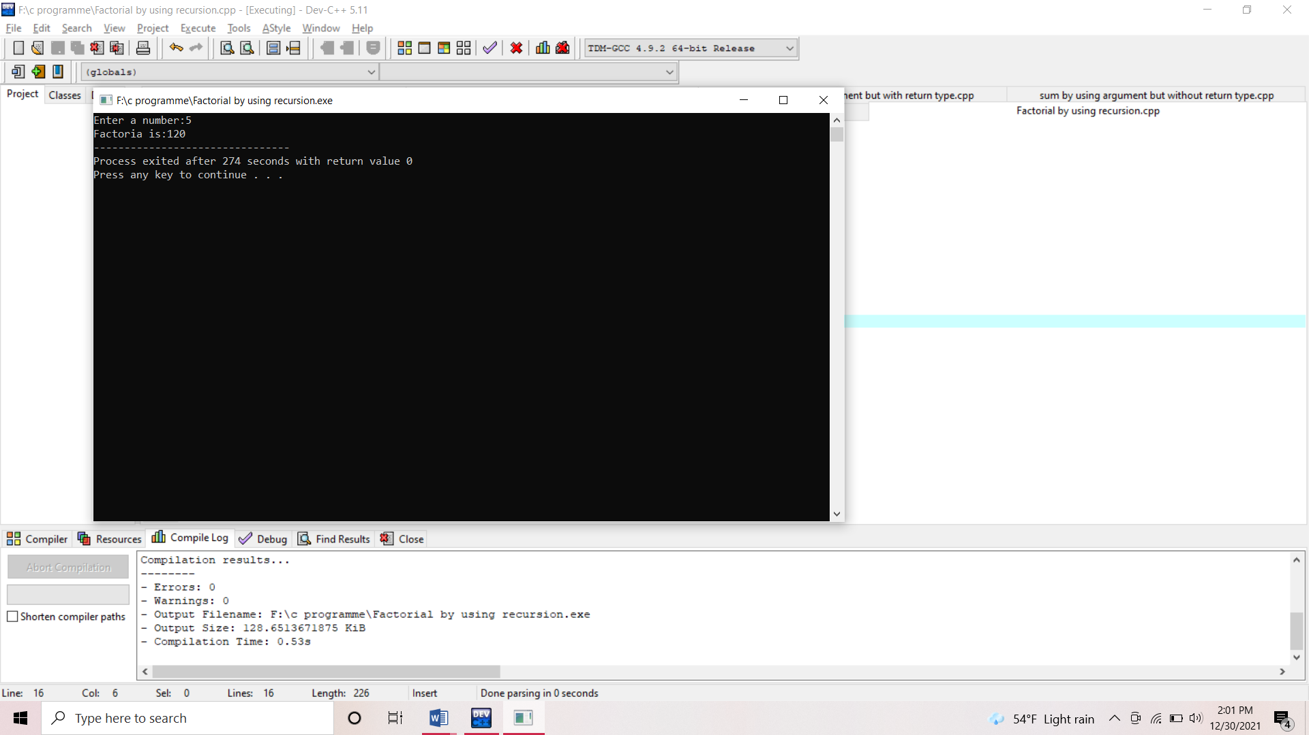

*8. WAP to find the Fibonacci series using recursion?*

#include<stdio.h>

int fibo(int n)

{

if(n==0)

return(0);

else if(n==1)

return(1);

else

return(fibo(n-1)+fibo(n-2));

}

int main()

{

int i,a;

printf("Enter a numbers of terms:");

scanf("%d",&a);

for(i=0;i<a;++i)

{

printf("%d",fibo(i));

}

return(0);

}

Output is:

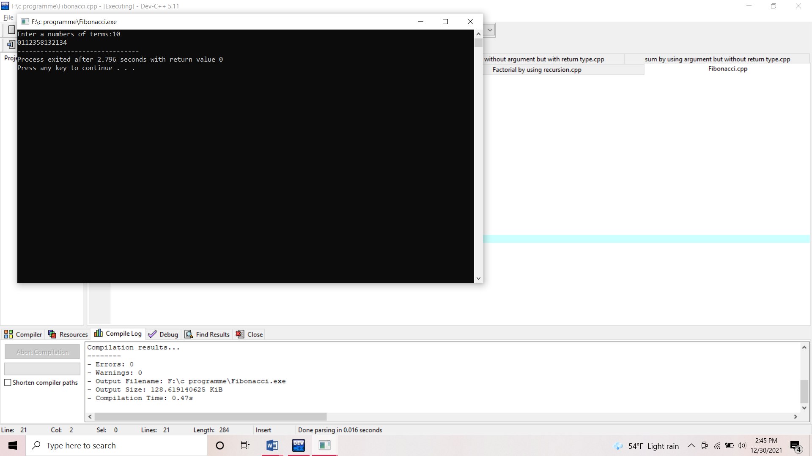

9. WAP to find the Simple Interest by using function without both argument and return type?

#include<stdio.h>

int Si()

{

float p,t,r,Si;

printf("Enter Principle,Time and Time:");

scanf("%f%f%f",&p,&t,&r);

Si=(p\*t\*r)/100;

printf("The Simple Intrest is:%f",Si);

return(0);

}

int main()

{

Si();

return(0);

}

Output is:

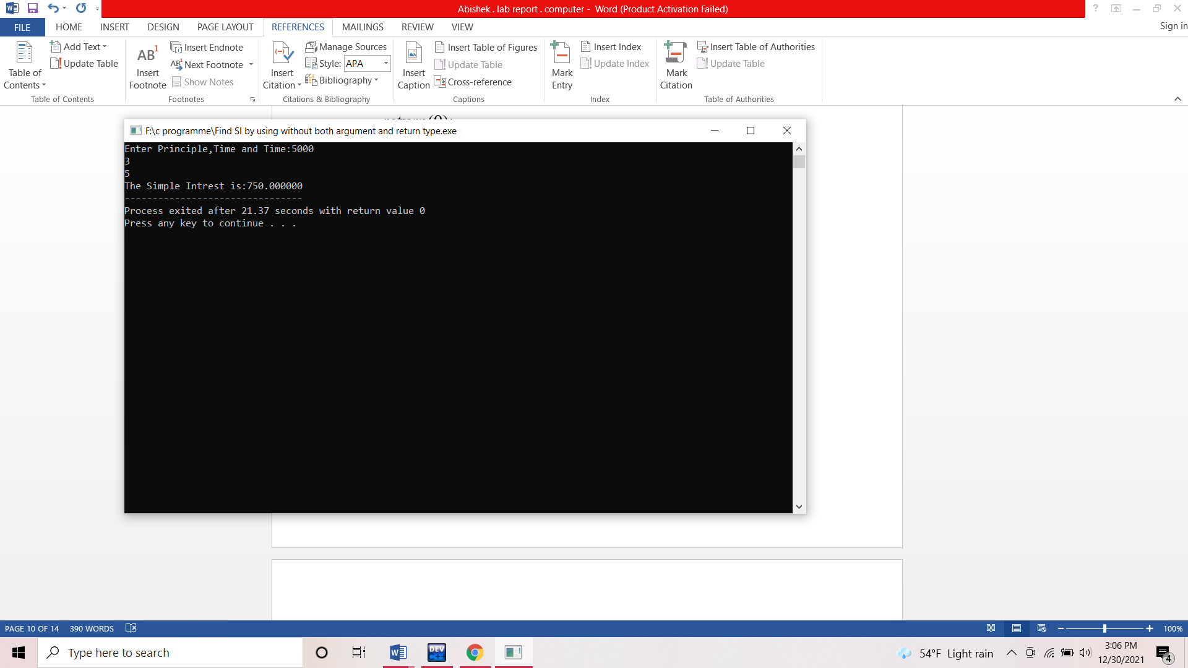

10.WAP to find the simple interest by using function without argument and with return type?

#include<stdio.h>

float SimpleIntrest()

{

float P,T,R,Si;

printf("Enter the value of P,T,R");

scanf("%f%f%f",&P,&T,&R);

Si=(P\*T\*R)/100;

return(Si);

}

int main()

{

float Si1;

Si1=SimpleIntrest();

printf("The SimpleIntrest is%f",Si1);

return(0);

}

Output is :

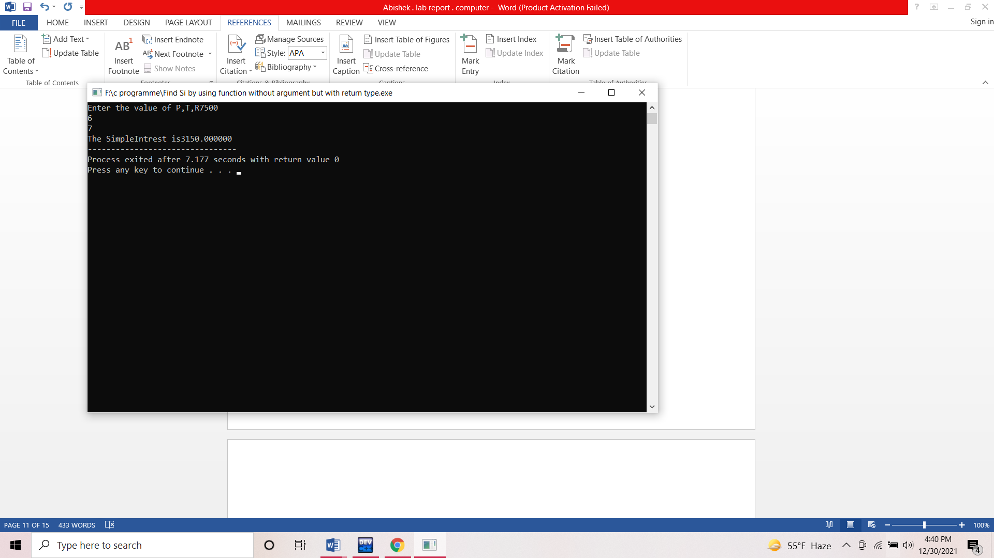

11. WAP to find the simple interest by using function with both argument and return type?

#include<stdio.h>

float simpleinterest(float P,float T,float R)

{

float Si;

Si=(P\*T\*R)/100;

return(Si);

}

int main()

{

float P1,T1,R1,Si1;

printf("enter the value of P,T,R");

scanf("%f%f%f",&P1,&T1,&R1);

Si1=simpleinterest(P1,T1,R1);

printf("simpleinterest is%f",Si1);

return(0);

}

*Output is:*

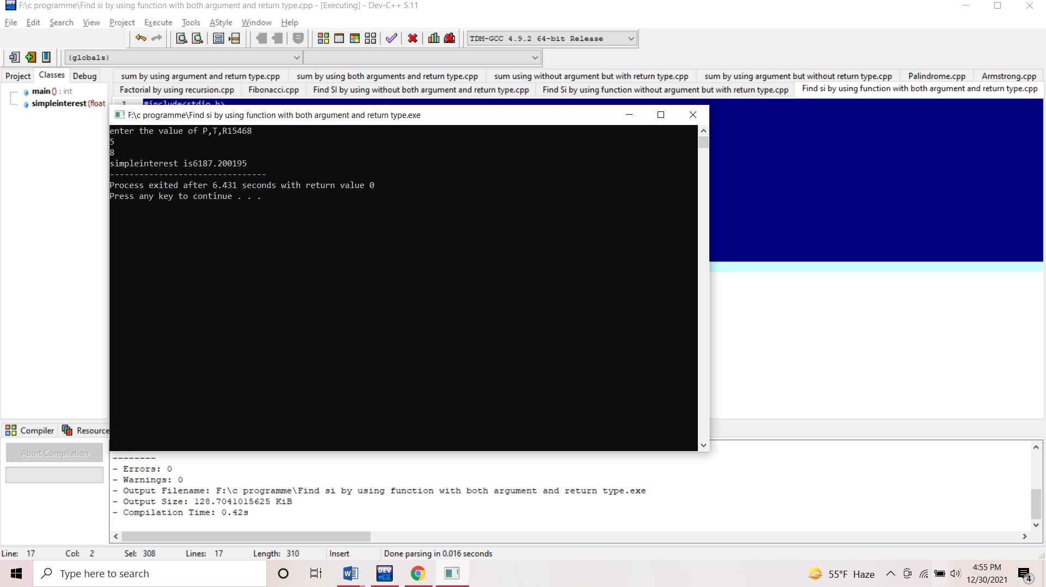

*12.WAP to find the multiplication table of any number?*

*#include<stdio.h>*

*int multiple()*

*{*

*int n,i;*

*printf("Enter any number:");*

*scanf("%d",&n);*

*for(i=1; i<=10;++i)*

*{*

*printf("%d\*%d=%d\n",n,i,n\*i);*

*}*

*}*

*int main()*

*{*

*multiple();*

*return(0);*

*}*

*Output is:*

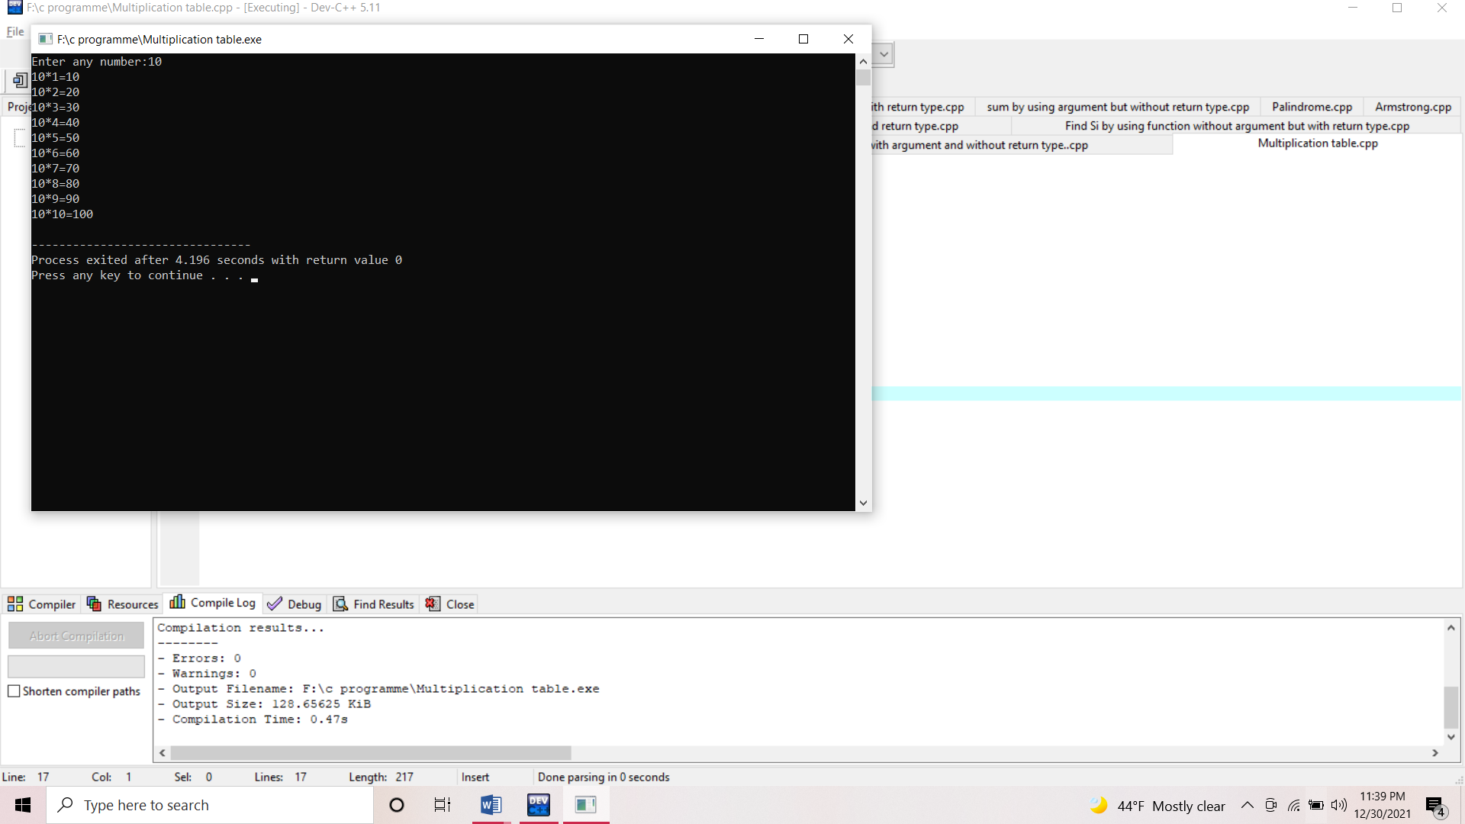

13.*WAP to find the greatest number among 3 numbers by using function with argument but without return type?*

*#include<stdio.h>*

*int greatest(int a, int b, int c)*

*{*

*int greatest;*

*if(a>b && a>c)*

*greatest =a;*

*else if(b>a && b>c)*

*greatest=b;*

*else*

*greatest=c;*

*printf("%d is the greatest number",greatest);*

*return(greatest);*

*}*

*int main()*

*{*

*int n1,n2,n3;*

*printf("Enter any three numbers:");*

*scanf("%d %d %d",&n1,&n2,&n3);*

*greatest(n1,n2,n3);*

*return(0);*

*}*

*Output is:*

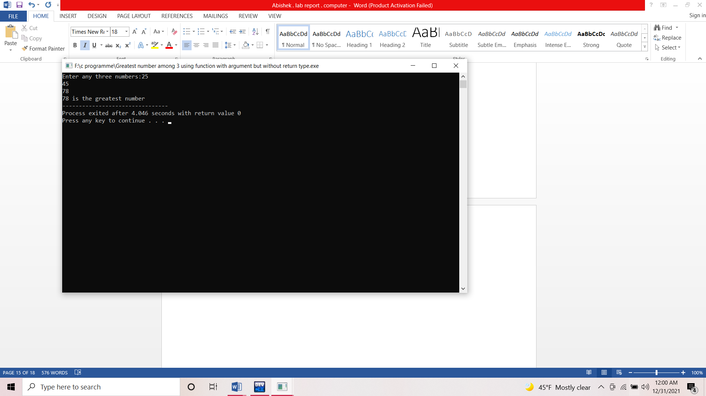

*14. WAP to find Si by using function with argument but without return type?*

*#include<stdio.h>*

*int simpleinterest(int p, int t, int r)*

*{*

*float Si;*

*Si=(p\*t\*r)/100;*

*printf("The Simple Interest is:%f",Si);*

*}*

*int main()*

*{*

*int n1,n2,n3,Si;*

*printf("Enter the value of P,T,R");*

*scanf("%d%d%d",&n1,&n2,&n3);*

*simpleinterest(n1,n2,n3);*

*return(0);*

*}*

*Output is:*

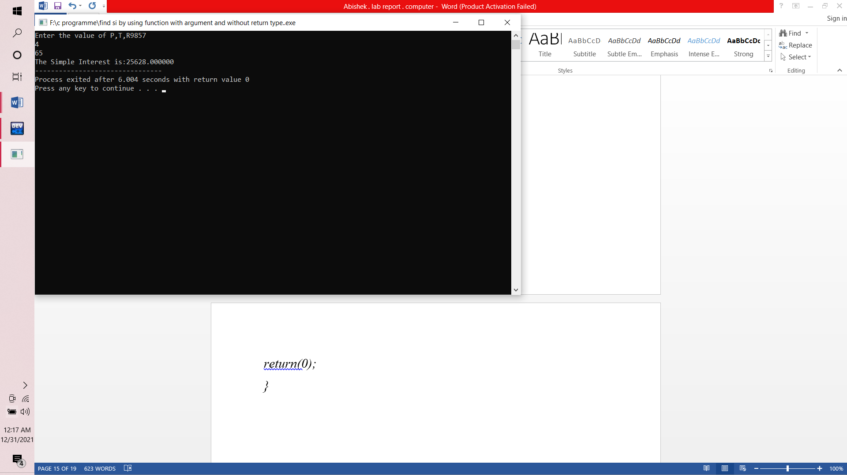

15.

WAP to store the info. of employees with name,eid,salary as member and update the salaray by 10 percent

#include <stdio.h>

int main()

{

int i;

float sal[20];

struct employe

{

char name[30];

int eid;

float salary;

} em[20];

for(i=0;i<20;++i)

{

printf("Enter name of employee %d", i+1);

scanf("%s", &em[i].name);

em[i].eid=i+1;

printf("Enter the salary of employee %d:", i+1);

scanf("%f", &em[i].salary);

}

for(i=0;i<20;++i)

{

sal[i]=em[i].salary + 0.1\*em[i].salary;

}

printf("EID\tName\tprevious salary\tupdated salary\n");

for(i=0;i<20;++i)

{

printf("%d\t%s\t%f\t%f\n",em[i].eid,em[i].name,em[i].salary,sal[i]);

}

return 0;

}